Join us in celebrating CAP Month 2026! Below are Facebook and Instagram graphics and post copy you can use this April. You can co-brand the graphics with your logo and share the following messages along with KCSL and other state partners. Full-resolution images can be found at kcsl.org/resources/cap-month/#social-media.

EXAMPLE:
Facebook Instagram
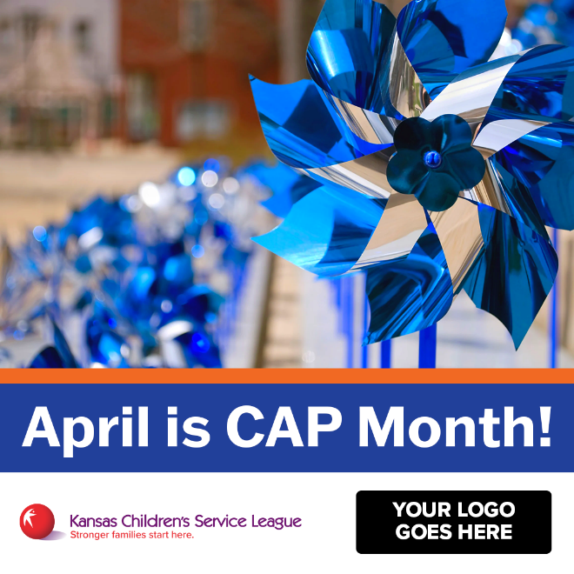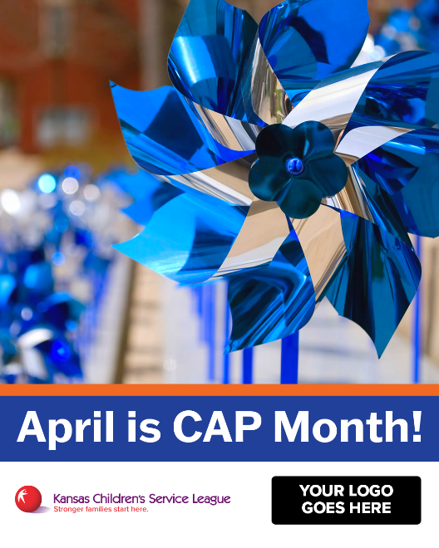

Co-Branding Tips:
- Use a PNG of your logo to avoid a white background.
- Place your logo in the designated blank shape and leave space around both logos.
- Tag us: @MyKCSL on Facebook and @kansaschildren on Instagram.

FACEBOOK
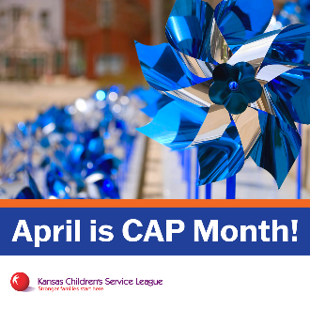 | - APRIL 1 – Welcome to CAP Month  POST COPY:  This month, [YOUR ORG] joins Kansas Children's Service League to celebrate the Pinwheels of Possibility and the power of strengthen families before crisis occurs. Prevention is possible. And it starts with all of us.  #PinwheelsofPossibility #CAPMonthKS
 | - APRIL 6 – Wear Blue Day Save the Date  POST COPY:  SAVE THE DATE: On April 10, Kansas will turn blue for Wear Blue Day. 💙 Wearing blue shows your commitment to prevention and strong Kansas families!  #WearBlueDay2026 #PinwheelsofPossibility #CAPMonthKS
Share a picture or video of your team wearing blue! | - APRIL 10 – Share Your Wear Blue Day Photos/Videos  POST COPY:  It’s Wear Blue Day! 💙 Today, we wear blue for prevention. Every action adds momentum to the movement centered on supporting families and helping them thrive.  #WearBlueDay2026 #PinwheelsofPossibility #CAPMonthKS
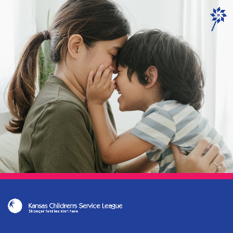 | - APRIL 13 – The Facts  POST COPY:  The facts matter.  ➡️1 in 7 children experience abuse or neglect each year.  ➡️Support early = stronger families.  ➡️Strong families = safer children.  Prevention is not reactive. It’s proactive.  #PinwheelsofPossibility #CAPMonthKS
 | - APRIL 16 – Why Prevention Matters  POST COPY:  Prevention means creating the right conditions.  ⭐Safe housing.  ⭐Health care access.  ⭐Strong community connections.  ⭐Voluntary home visiting.  When families have what they need, children thrive. That’s prevention in action.  #CAPMonthKS #PinwheelsofPossibility
 | - APRIL 17- Be a Champion for Families  POST COPY:  Preventing child abuse and neglect is a shared responsibility. Be a champion for families by supporting prevention in your community.  #PinwheelsofPossibility #CAPMonthKS

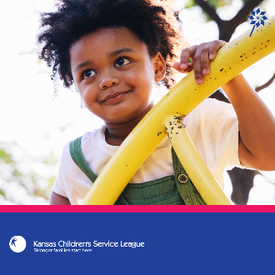 | - APRIL 22 - Possibility  POST COPY:  Every child is born with promise. Pinwheels of Possibility reminds us what’s possible when we invest in families and act early.  #PinwheelsofPossibility #CAPMonthKS
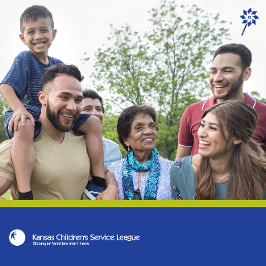 | - APRIL 30- Prevention is Year-Round  POST COPY:  CAP Month may end, but prevention continues year-round. And so does our commitment to strengthening Kansas families.  #CAPMonthKS #PinwheelsofPossibility #PreventionWorks

INSTAGRAM
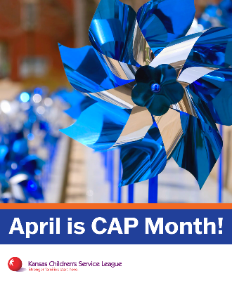 | - APRIL 1 - Welcome to CAP Month  POST COPY:  It’s CAP Month 💙Pinwheels of Possibility reminds us that when families have the support they need, children thrive. Join us all month long.  #PinwheelsofPossibility #CAPMonthKS
 | - APRIL 6 - Wear Blue Day Save the Date  POST COPY:  Kansas turns blue on April 10 💙 Wear blue to show your commitment to prevention and the power of possibility for every child. Let’s flood feeds with blue!  #WearBlueDay2026 #CAPMonthKS #PinwheelsofPossibility
Share a picture or video of your team wearing blue! | - APRIL 10 – Share Your Wear Blue Day Photos/Videos  POST COPY:  We’re blue for prevention 💙Let’s show how Kansas shows up for families.  #WearBlueDay2026 #PinwheelsofPossibility #CAPMonthKS
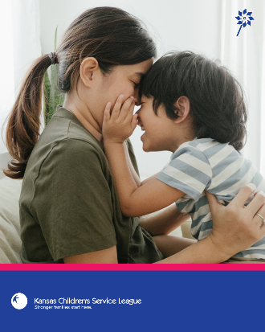 | - APRIL 13 – The Facts  POST COPY:  The facts matter.  ➡️1 in 7 children experience abuse or neglect each year.  ➡️Support early = stronger families.  ➡️Strong families = safer children.  Prevention is not reactive. It’s proactive.  #PinwheelsofPossibility #CAPMonthKS
 | - APRIL 16 – Why Prevention Matters  POST COPY:  Prevention means creating the conditions families need to thrive, like stable housing, health care and strong community connections.  When we invest early, possibility expands.  #PinwheelsofPossibility#CAPMonthKS
 | - APRIL 17 – Be a Champion for Families  POST COPY:  Prevention takes all of us 💙 Be a champion for families this April. Together, we center families and build the conditions where every child can thrive.  #CAPMonthKS #PinwheelsofPossibility
 | - APRIL 22- Possibility  POST COPY:  Prevention makes possibility real. 💙  #PinwheelsofPossibility #CAPMonthKS
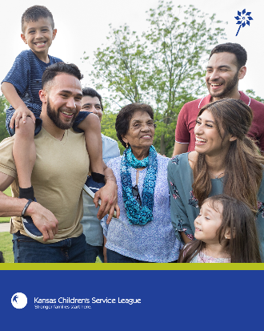 | - APRIL 30- Prevention is Year-Round  POST COPY:  April ends. Prevention doesn’t. Keep building strong families all year long!  #CAPMonthKS #PinwheelsofPossibility #PreventionWorks

